Geometry: Unit 6, Lesson H1
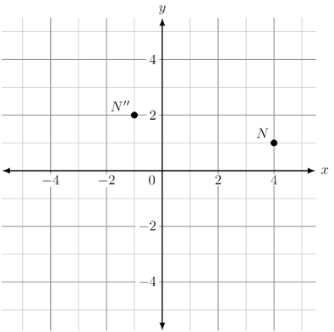
- Point $N$ and $N''$ are shown on the coordinate plane. What is the sequence of transformations that will map point $N$ onto point $N''$?

Reflect point $N$ over the $x$-axis, followed by a translation of $5$ units left and $3$ units up.

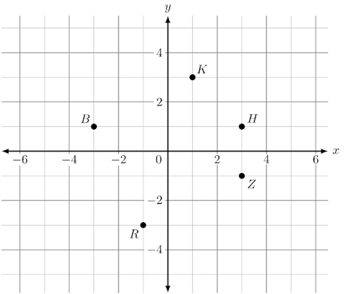
- Points $B$, $H$, $K$, $R$, and $Z$ are shown on the coordinate grid. What point is the result of rotating point $Z$ clockwise $90°$ about the origin?

Point $R$

- Are congruent figures always, sometimes, or never similar?

Always

